**Assignment Information and Goal**  
In this class assignment you will demonstrate a detailed knowledge of WordPress basic skills by creating a WordPress site and extending it with menus, images, themes, plugins, pages and posts and comments.   
The goal of this assignment is to demonstrate that you have learned how to create database tables and write PHP code to query their contents and display them on a WordPress page in a Custom WordPress Plugin.   
**Assignment questions are not as detailed as activity questions. The assignment is where you demonstrate understanding of the material.  
  
Read All Project Documents before Starting the Work**Please read this document completely before starting the project work.   
Please also read the template so that you understand what information, content, and screens you are required to capture and insert into the template file.

**Documents for This Assignment:**   
This is the assignment instructions document.   
It contains the information on the necessary tasks to be completed for the assignment.  
The other documents associated with this assignment are the assignment template, the website content, and the rubric.   
  
**Website Content document:**   
The Website Content document contains business information and all the necessary CMS web page content required to create the WordPress site.   
  
**Template File:**   
Please download, rename, complete and then submit the assignment template document to receive a grade for this assignment. Please provide partial screen captures where requested.  
The rubric provides detailed information on how the assignment is graded.  
**PLEASE DO NOT DELETE PARTS OR ALTER SECTION FORMATTING OF THIS TEMPLATE**

**Assignment Asset Folders and Website Content**   
There are asset folders that contain images and website page and post content.  
The asset folders contain images and content to use on the CMS website.   
Please use the content and image assets provided on the D2L CMS to complete the assignment.

**Asset Folders Information**There are no assets for this assignment. Please use your own images or past tutorial or assignment images and IPSUM content for Pages and Posts.

Please contact the instructors if you have questions about the assignment, content layout, or formatting.

**Part A - Student Information**

1. Download and save a copy of the Assignment 05 Template document
2. Rename the template document **[Your-Full-Name]-**Assignment05.docx
3. Go to the template and enter part A student information.

**Part B - Create WordPress CMS website on a Shared Web Host or Pantheon (PaaS) Platform or Codeanywhere (Your choice)**

1. If you are using a shared web host create an “In Directory” WordPress CMS website with the following attributes:  
   **Protocol:** http:// **Domain:** Select your default domain **In Directory:** assignment05”

**Site Name:** “Custom Plugin Assignment”

**Site Description:** “IT320 Assignment 05”  
**Enable Multisite (WPMU):** Do not enable Multisite

**Choose Language: Set language to the default of English  
Select Plugins:**

**Limit Login Attempts – Uncheck this option**

**Do not use the Classic Editor on this assignment:**

**Classic Editor – Do not Enable (**DO NOT CHECK**) this option**

**Advanced Options:**

Database Name: Use your web hosts default database name

Database Prefix: Use your Web hosts default database prefix

-OR-  
**For Pantheon:**

If you are creating a Pantheon WordPress 5.0 site, create a site with the following attributes:  
**Site Name:** “Assignment 05 WP CMS”

-OR-  
**For Codeanywhere:**

**Build a Codeanywhere WP Site –then Upgrade to version 5 & Edit Config files**

1. Fill out the Connection Wizard container form
   1. Name: [your lower case initials]Assignment5ca - no spaces all lowercase
   2. Choose a WordPress stack: **I use WordPress Ubuntu 14.03**
   3. Do not enable **Always on** – This wont work with our accounts
2. Be patient while Codeanywhere deploys your container server
   1. This may take a while
3. Select the link to access your web application over HTTPS protocol  
   - this loads the WordPress build script
4. Configure your WordPress Site as follows:
   1. Select English and continue
   2. Site Title: **[Your Initials] –Assignment 05 CA**
   3. Username: enter your username – do not use the word admin
   4. Password: enter a strong password
   5. Email: use your Codeanywhere account email
   6. Search Engine Visibility – Select (check) Discourage indexing

Go to the template and record website creation settings in Part B.

Part C - Extend your WordPress site with Images, Menu, Pages, Categories, Tags, Posts and Comments   
Note:   
Comments are essential to getting full credit for your work on the custom plugins.

1. Add at least 3 images to the Media Library
2. Change the Theme to Camer
3. Add a menu to the WordPress site

Menu check boxes to select based on Camer Theme selection:  
(1) Automaticly add new top-level pages to this menu  
(2) Primary Menu

1. Configure the WordPress site to allow comments
2. Configure each Page and Post to allow comments
3. Add 3 Pages named Page Test 1 – Page Test 3 – each with 2 images on each page
4. Add One Category named “**IT320”**
5. **Add a Tags named “Test”, “Prospect”, and “Act”**
6. Add 2 Posts named “Post Test 1” – “Post Test 2”
   * Add Category of “IT320”
   * Add 2 Tags of your choice
   * Add 2 images on each Post from the Media Library
7. Add 2 comments to each Page
8. Add 2 comments to each Post
9. Approve all Page and Post comments
10. Go to the template and record website creation settings in Part C.

Part D – Create and deploy a Custom WordPress Plugin – Posts Reader

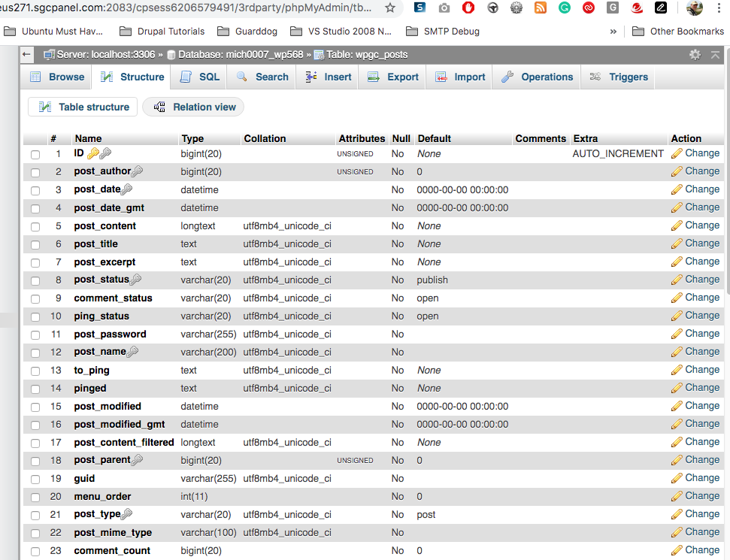

1. Install and activate the Classic Editor Plugin
2. Create a new WordPress custom plugin named posts-reader that queries the posts table and displays the iterated table contents in an HTML table on a Page named   
   “Posts Reader” on your WordPress site for the following Posts table columns:
   * ID
   * post_title
   * post_status
   * comment_status
   * post_type

NOTE: these are different columns than we used for the tutorial, but you can and should use the tutorial custom plugin file as a base for this work.

1. Additional processing on DB table iteration – Only display the DB table row If the   
   “post-title” is not an empty string. In other words. If the post-title is empty, do not add the DB table data to the output HTML table.   
   HINT PHP function strlen  
   String length function (strlen) Website Links:  
   <https://www.php.net/manual/en/function.strlen.php>
2. Deploy the Posts Reader custom plugin on your WordPress site
3. Add a Page to execute your Posts reader plugin
4. Go to the template and record the requested answers at Part D.

Example Post Reader Output HTML Table (Notice No blank Post Title Entries)

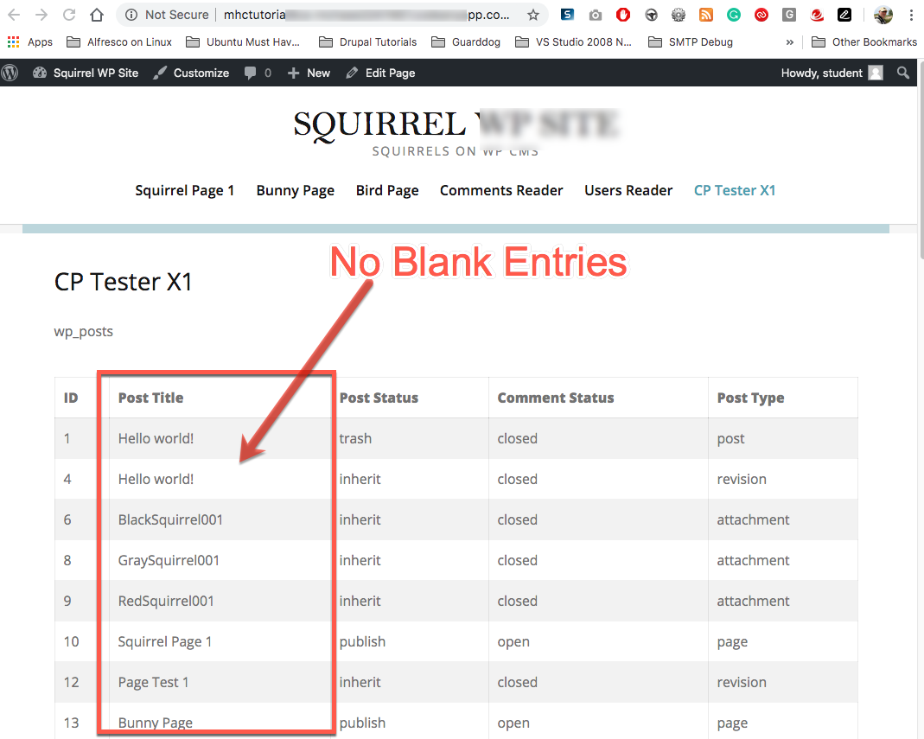

Part E – Create and deploy a Custom WordPress Plugin –Terms Reader  
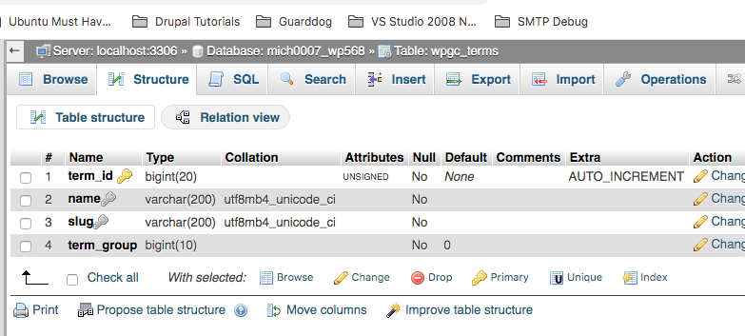

1. Verify that the Classic Editor Plugin is installed and activated
2. Create a new WordPress custom plugin named terms-reader that queries the terms table and displays the iterated table contents in an HTML table on a Page named   
   “Terms Reader” on your WordPress site for the following Terms table columns:
   * term_id
   * name
   * slug
3. Additional display processing:  
   Do not display terms DB data row items where the “name” is the string value “**Uncategorized**”.

Hint – Use the String Compare PHP Function (strcmp)   
https://www.php.net/manual/en/function.strcmp.php  
<https://www.w3schools.com/php/func_string_strcmp.asp>  
Also – review D2L strcmp examples in Module 05 – PHP Examples

1. Deploy the Terms Reader custom plugin on your WordPress site
2. Add a Page to execute your Terms Reader plugin
3. Go to the template and record the requested answers at Part E.

Example Terms HTML Output display:  
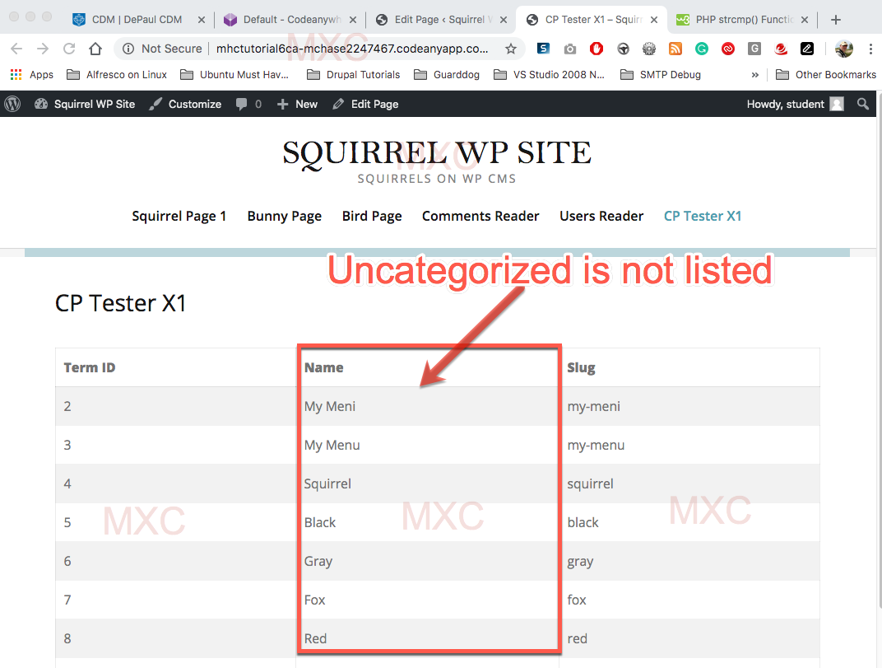

Part F – Create and deploy a Custom WordPress Plugin – Term-Taxonomy Reader

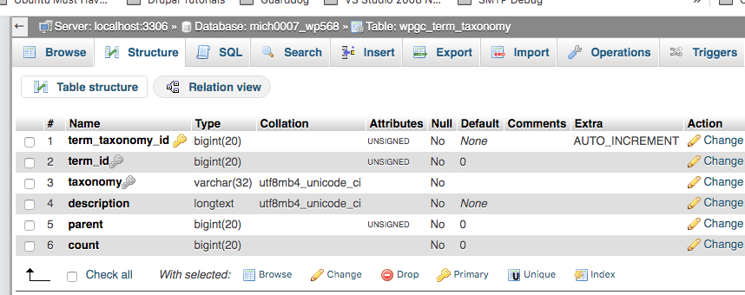

1. Verify that the Classic Editor Plugin is installed and activated
2. Create a new WordPress custom plugin named term-taxonomy-reader that queries the term-taxonomy table and displays the iterated table contents in an HTML table on a Page named “Term Taxonomy Reader” on your WordPress site for the following Taxonomy table columns:
   * term_taxonomy_id
   * term_id
   * taxonomy
   * count
3. Additional output display processing:  
   Only display row items in the HTML output table where the row “**coun**t” value is greater than zero.
4. Deploy the Taxonomy Reader custom plugin on your WordPress site
5. Add a Page to execute your Taxonomy Reader plugin
6. Go to the template and record the requested answers at Part F.

Example Term-Taxonomy Output:  
  
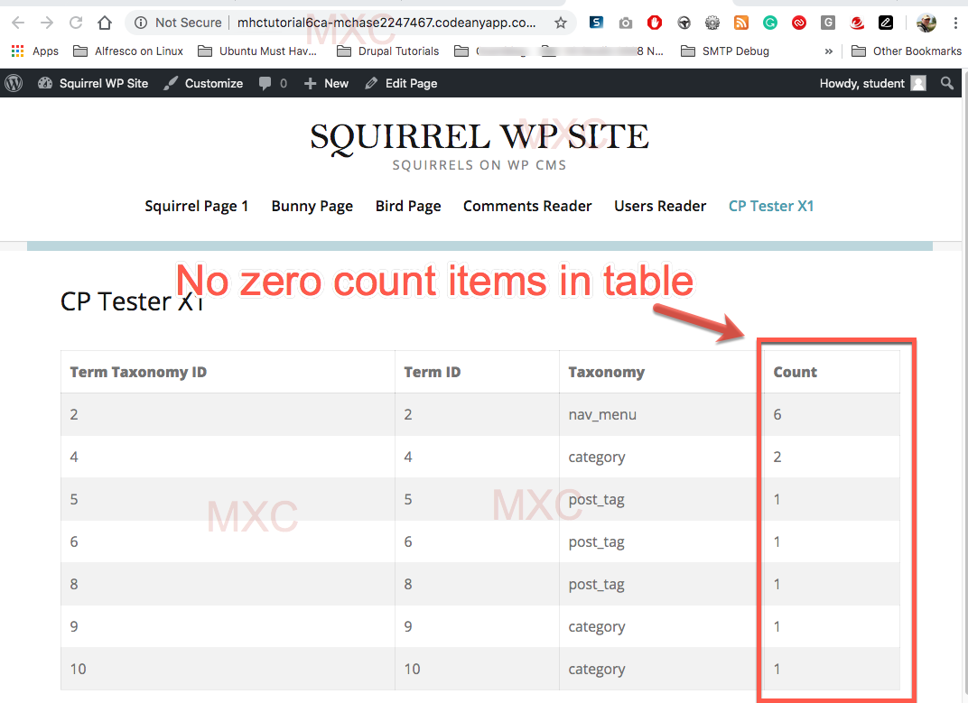

PART G - Assignment Wrap-up  
Go to the template and record the requested answers at Part G.

**Congratulations. You have completed this assignment.**

Submit your completed Assignment 05 Template to D2L.